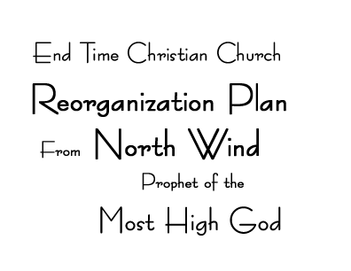
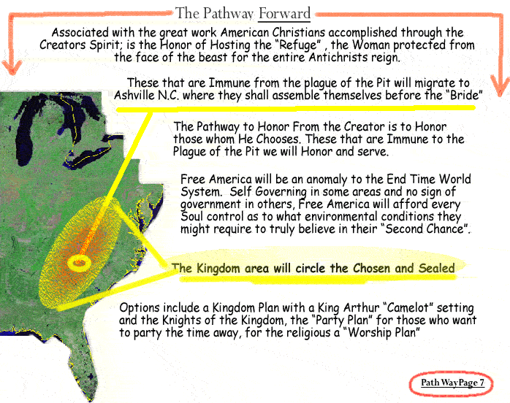
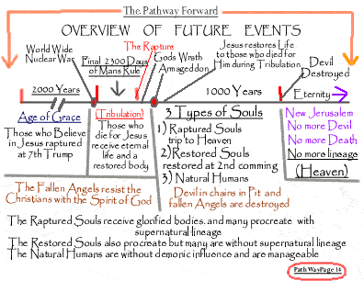
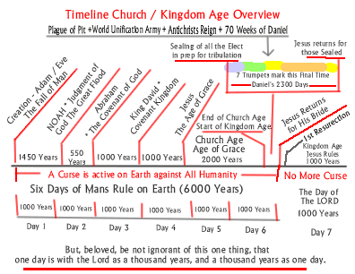
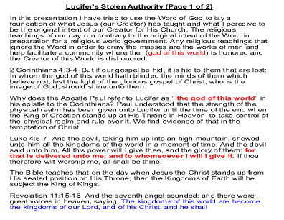
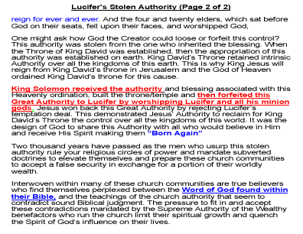

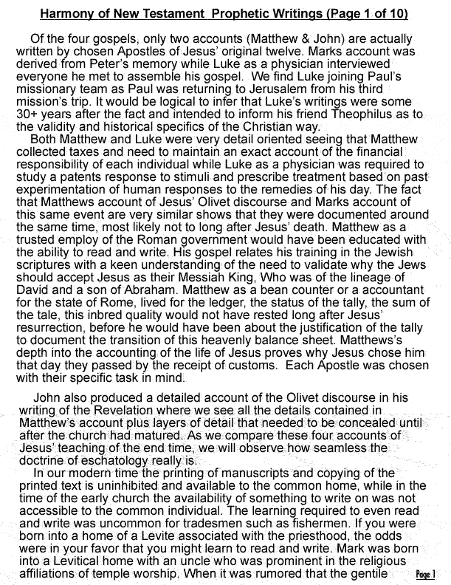
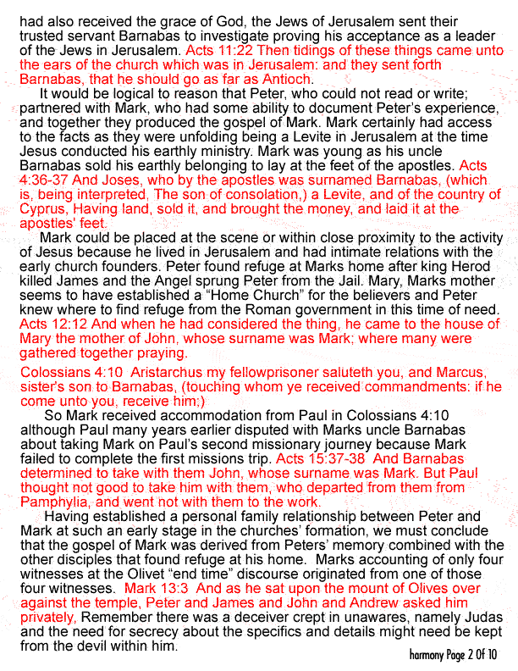
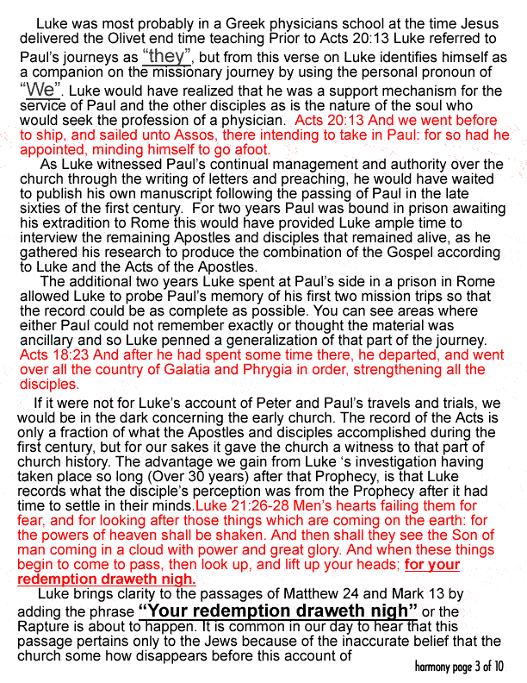
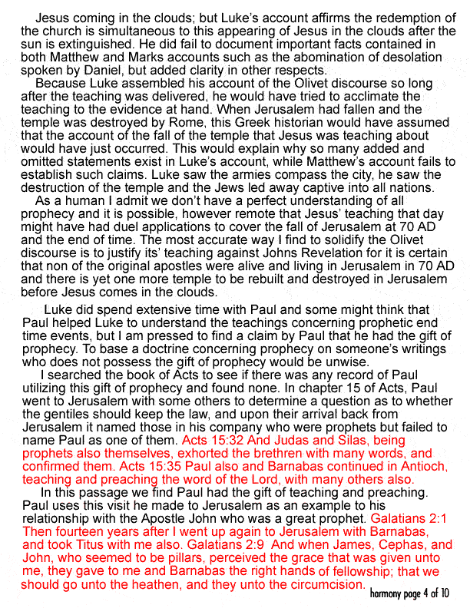
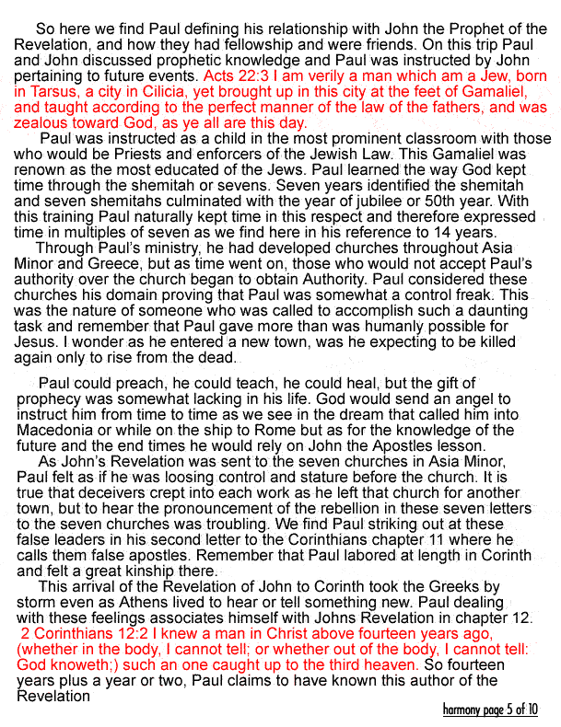
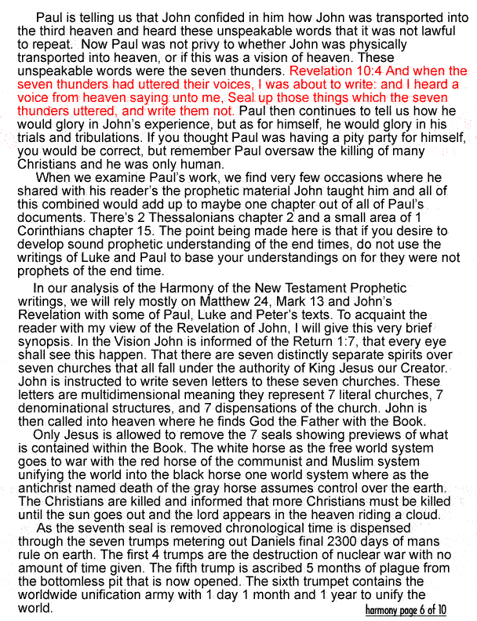
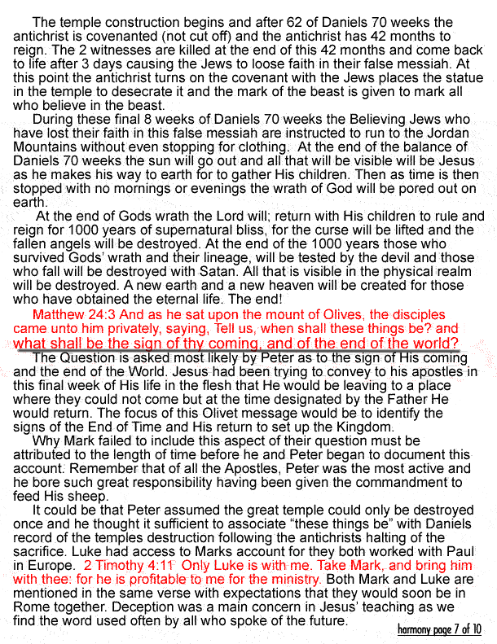
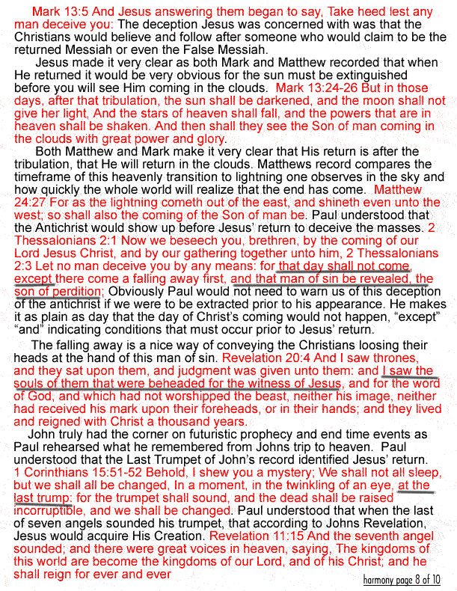
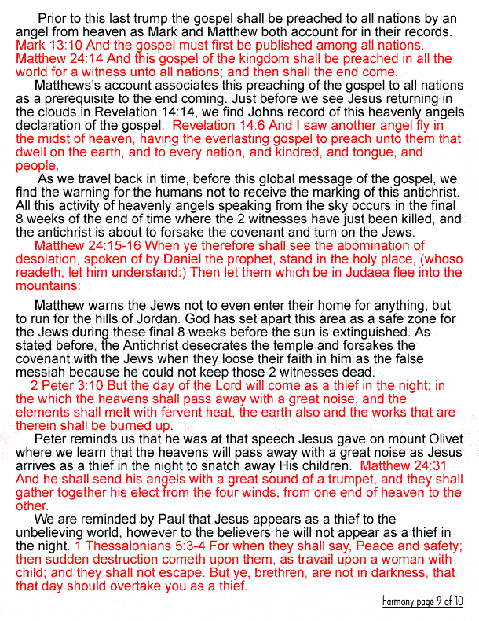
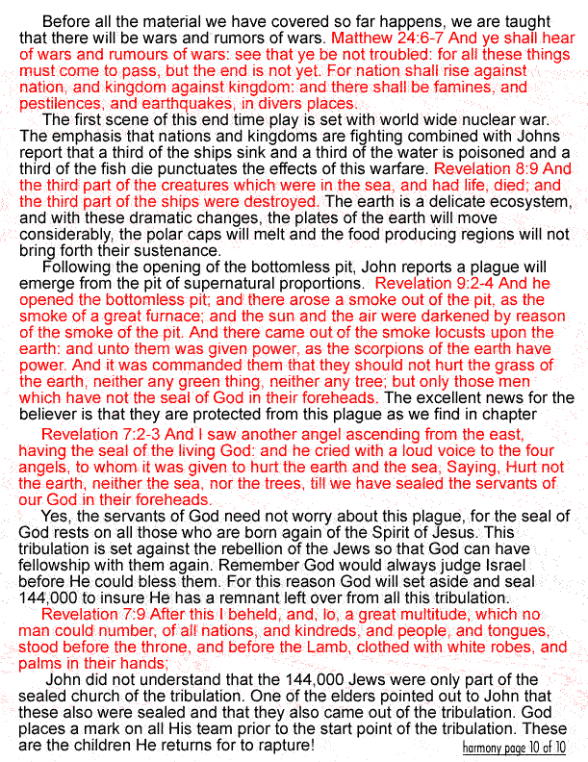
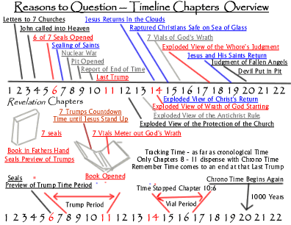

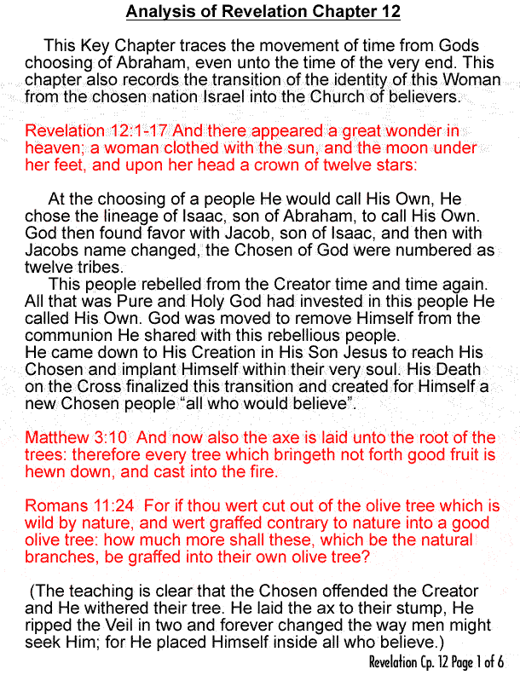
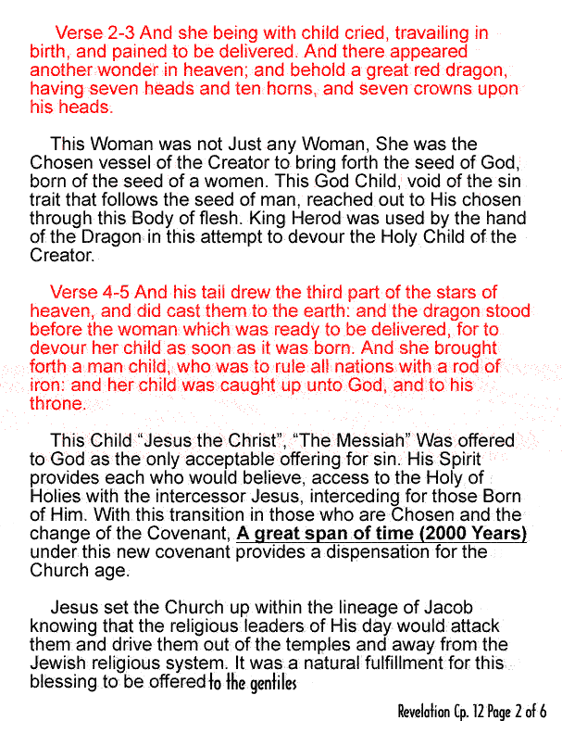
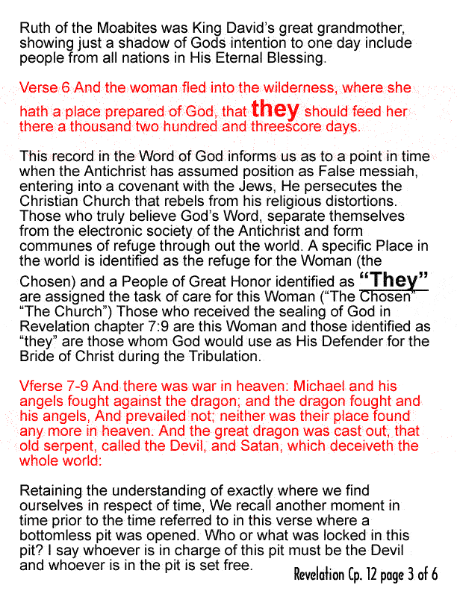
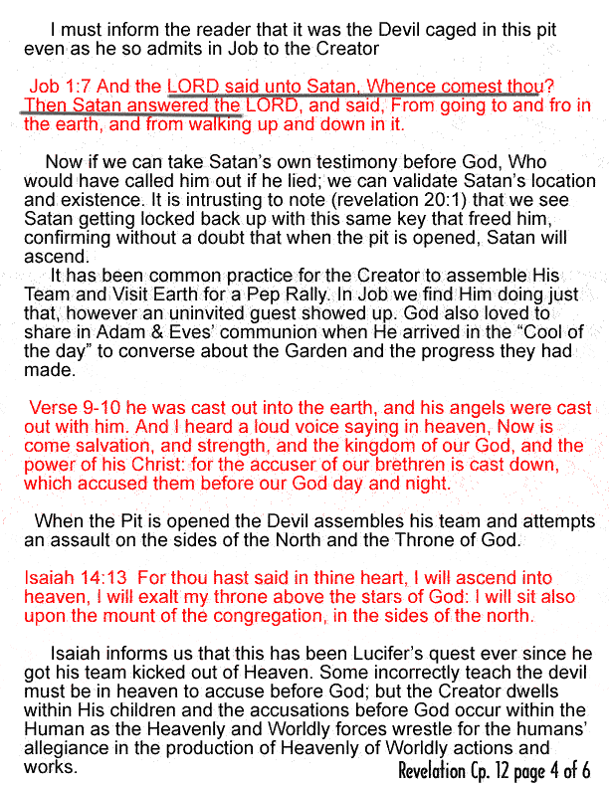

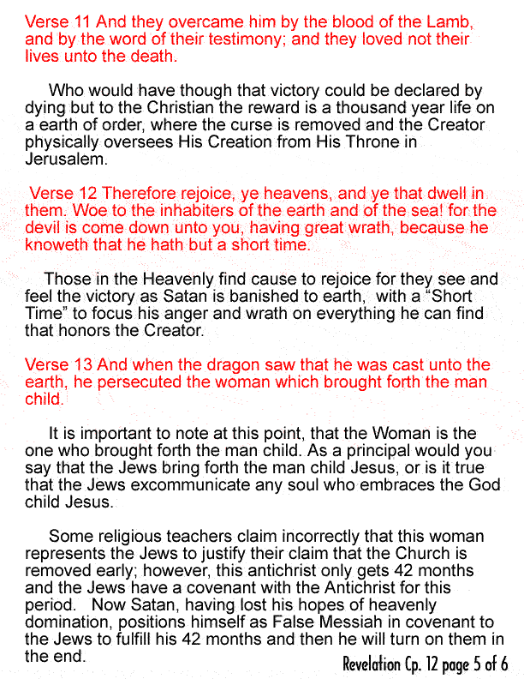
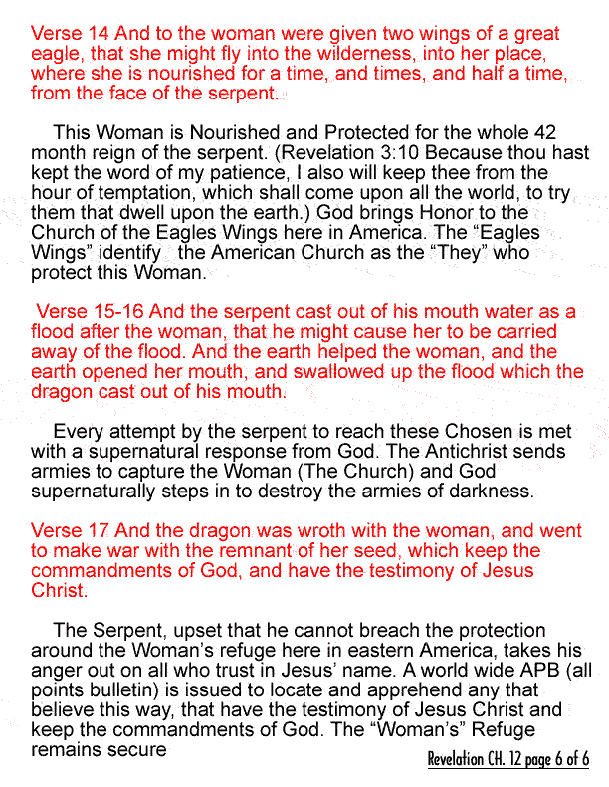
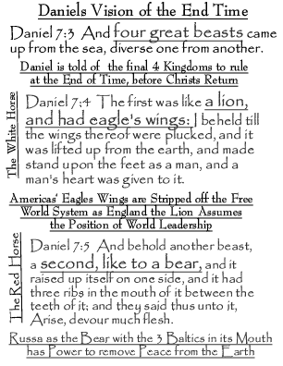

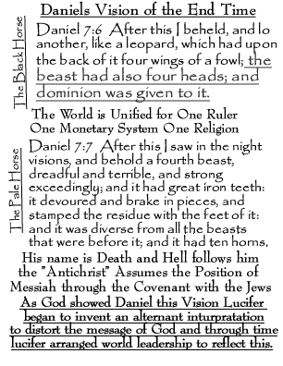

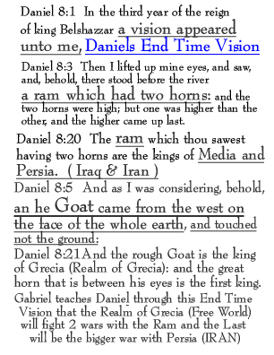

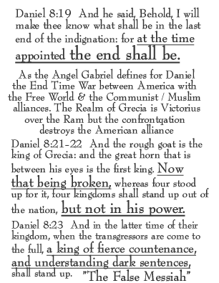

Biblical Analysis of Daniel Chapter 11 & 12

To understand chapter 11, I start in a place where I can positively determine the Person and the Position of the Prime Character and his relevance to the World Events taking place.
In this analysis we find someone who identifies as one of the signatory’s of the Holy Covenant that is signed with the Jews. This person is also identified as the one who breaks this Holy Covenant and desecrates the Temple of the Jews. This same Person is also said to Kill the Holy People.

The end of the 1st King of the North:
Daniel 11:19 Then he shall turn his face toward the fort of his own land: but he shall stumble and fall, and not be found.
In order for the Antichrist to be sold as God, the religious leaders will teach that this first King was the Antichrist

The end of the 2nd King of the North:
Daniel 11:20 Then shall stand up in his estate a raiser of taxes in the glory of the kingdom: but within few days he shall be destroyed, neither in anger, nor in battle.

The 3rd King of the North, “The Antichrist”

“Prince of the Covenant”
Daniel 11:21 And in his estate shall stand up a vile person, This is the Antichrist who has 42 months to finish the course of the rule of man on earth to whom they shall not give the honour of the kingdom: but he shall come in peaceably, and obtain the kingdom by flatteries. And with the arms of a flood shall they be overflown from before him, and shall be broken; yea, also the prince of the covenant. And after the league (League or Covenant) made with him he shall work deceitfully:

This Vile One has no intension of fulfilling the covenant, He just knows that the Creator is very interested in His People “the Jews” and so this Evil Vile Prince of the Covenant pretends to be the Messiah for 42 Months

for he shall come up, and shall become strong with a small people. He shall enter peaceably even upon the fattest places of the province; and he shall do that which his fathers have not done, nor his fathers' fathers; he shall scatter among them the prey, and spoil, and riches: yea, and he shall forecast his devices against the strong holds, Every Asset on earth is taken and brought under the control of this World Dictator even for a time.

And he shall stir up his power and his courage against the king of the south with a great army; and the king of the south shall be stirred up to battle with a very great and mighty army; but he shall not stand: for they shall forecast devices against him. Yea, they that feed of the portion of his meat shall destroy him, The king of the South is overthrown from within his own Company and his army shall overflow: and many shall fall down slain. And both these kings' hearts shall be to do mischief, and they shall speak lies at one table; but it shall not prosper: for yet the end shall be at the time appointed.

Notice that the “End of Time” is referred to as the “Time Appointed”. This “Appointed Time” is at the End of the Antichrist’ 42 month reign, when the 2 Witnesses are killed & come to life again. The Jews loose respect in their false messiah and then the Antichrist turns on the Jews to kill them. They are instructed to flee immediately to the Jordan Mountains until Jesus Stands up on His Throne to Return for His Children.

Then shall he return into his land with great riches; and his heart shall be against the holy covenant; Antichrists heart is turned against the “holy Covenant and he shall do exploits, and return to his own land.

Daniel 11:29 At the “time appointed” he shall return, and come toward the south; but it shall not be as the former,
Yes even the Antichrist is a looser in the end or as the latter. For the ships of Chittim shall come against him: therefore he shall be grieved, and return, and have indignation against the holy covenant: so shall he do; he shall even return, and have intelligence with them that forsake the holy covenant.

The Covenant with the Jews allowing them to offer sacrifices and conduct worship for the Antichrist “False messiah”

And arms shall stand on his part, and they shall pollute the sanctuary of strength, and shall take away the daily sacrifice, and they shall place the abomination that maketh desolate.
Here at the end of the Antichrists reign is the abomination of desolation where the Antichrist places the Statue of the Beast in the Holy of Holies and the Beast comes alive to institute the Mark of the Beast. Angels from Heaven are dispatched to warn the whole world not to receive the Mark of the Beast.(Revelation 14:9) The following verses expound on some of the specifics of this final 42 month reign of the Antichrist

And such as do wickedly against the covenant shall he corrupt by flatteries: but the people that do know their God shall be strong, and do exploits. And they that understand among the people shall instruct many: yet they shall fall by the sword, and by flame, by captivity, and by spoil, many days.

Now when they shall fall, they shall be holpen with a little help: but many shall cleave to them with flatteries. And some of them of understanding shall fall, to try them, and to purge, and to make them white, even to the time of the end: because it is yet for a time appointed.

The Following paragraph, much like Revelations chapter 13, displays for us what the devil will be like when he receives his turn to inhabit the Human body. Everything is about him and the things of the physical realm And the king shall do according to his will; and he shall exalt himself, and magnify himself above every god, and shall speak marvellous things against the God of gods, and shall prosper till the indignation be accomplished: for that that is determined shall be done. Neither shall he regard the God of his fathers, nor the desire of women, nor regard any god: for he shall magnify himself above all. Remember this guy only has 42 months to reign. He has a covenant with the Jews to lead worship in the temple for the 42 months. The 2 Witnesses cast Plagues of the Judgment of God for the 42 months.

But in his estate shall he honour the God of forces: and a god whom his fathers knew not shall he honour with gold, and silver, and with precious stones, and pleasant things. Thus shall he do in the most strong holds with a strange god, whom he shall acknowledge and increase with glory: and he shall cause them to rule over many, and shall divide the land for gain.

Daniel 11:40 And at the time of the end shall The length of Appointed Time According to Daniel Chapter 12 is the difference between 1290 days and 1335 days or 45 days.

Daniel 12:11-12 And from the time that the daily sacrifice shall be taken away, and the abomination that maketh desolate set up, there shall be a thousand two hundred and ninety days. Blessed is he that waiteth, and cometh to the thousand three hundred and five and thirty days.

The king of the south push at him: and the king of the north shall come against him like a whirlwind, with chariots, and with horsemen, and with many ships; and he shall enter into the countries, and shall overflow and pass over. He shall enter also into the glorious land, and many countries shall be overthrown: but these shall escape out of his hand, even Edom, and Moab, and the chief of the children of Ammon.

Remember that the Jews are told to flee to the Mountains of Jordan where Edom and Moab reside

He shall stretch forth his hand also upon the countries: and the land of Egypt shall not escape. But he shall have power over the treasures of gold and of silver, and over all the precious things of Egypt: and the Libyans and the Ethiopians shall be at his steps. But tidings out of the east and out of the north shall trouble him: therefore he shall go forth with great fury to destroy, and utterly to make away many.

And he shall plant the tabernacles of his palace between the seas in the glorious holy mountain; yet he shall come to his end, and none shall help him.

Daniel 12:1-4 And at that time shall Michael stand up Jesus Stands Up, the great prince which standeth for the children of thy people: and there shall be a time of trouble, such as never was since there was a nation even to that same time:
This is the climax of the rule of darkness on earth. The earth is all but completely destroyed and the Creator has Risen from His seated position to destroy all of the fallen angels

and at that time thy people shall be delivered, every one that shall be found written in the book. And many of them that sleep in the dust of the earth shall awake, some to everlasting life, and some to shame and everlasting contempt.

It is the same story we are taught in the New Testament, that at that Last Trump in Revelation 11:15 the Creator Stands Up to assume control of His Creation & Rule this Physical Realm 1000 Years

And they that be wise shall shine as the brightness of the firmament; and they that turn many to righteousness as the stars forever and ever. But thou, O Daniel, shut up the words, and seal the book, even to the time of the end: many shall run to and fro, and knowledge shall be increased.

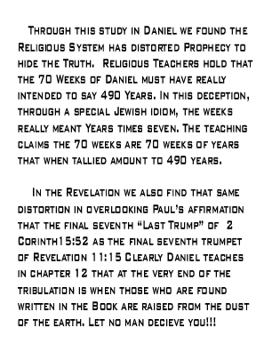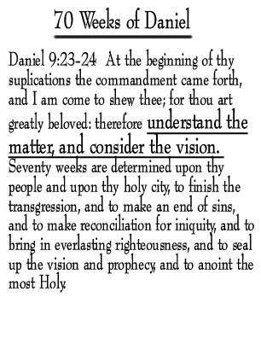

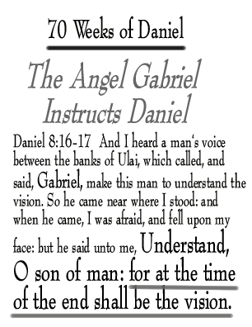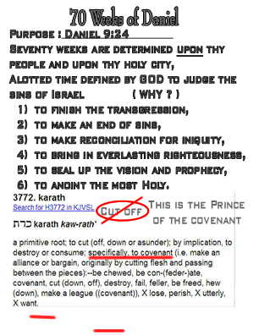
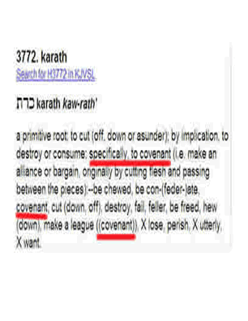
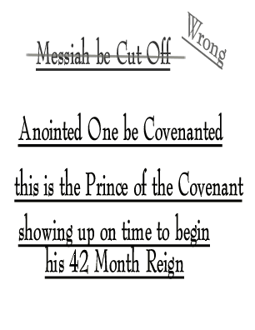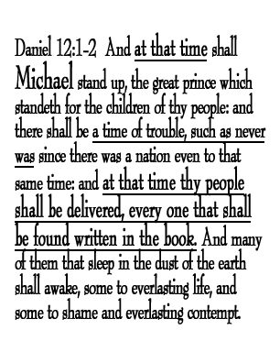

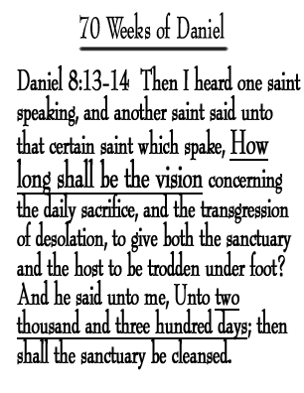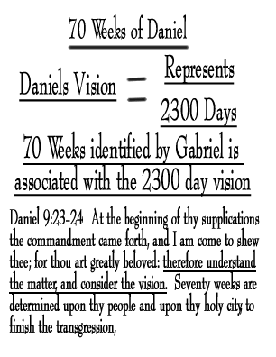

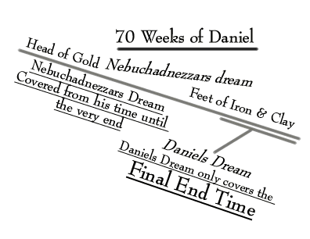
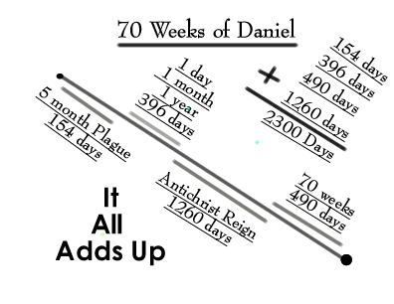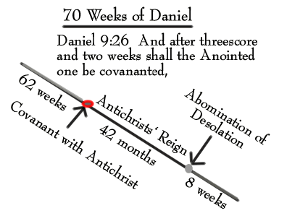
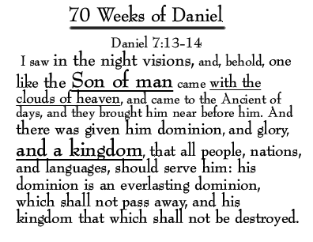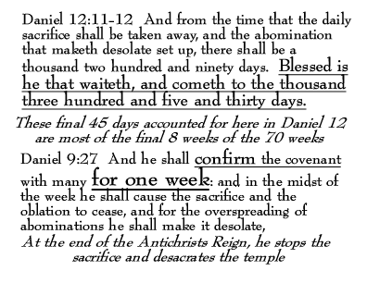
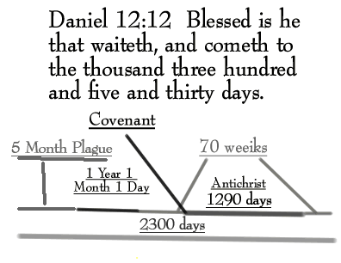
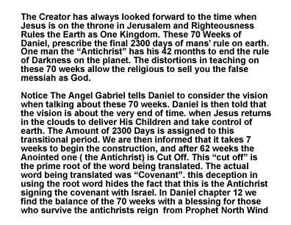

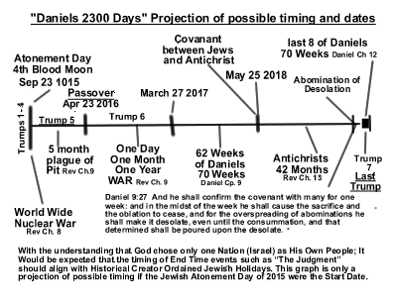

Analysis of Daniel Chapter 7

Daniel 7:1-28 In the first year of Belshazzar king of Babylon (Notice God waits until Nebuchadnezzar was dead to further expound on Daniels Prophetical Training.) Daniel had a dream and visions of his head upon his bed: then he wrote the dream, and told the sum of the matters. Daniel spake and said, I saw in my vision by night, and, behold, the four winds of the heaven strove upon the great sea.
And four great beasts came up from the sea, diverse one from another.
(4 Winds points to a moment in time mentioned in Revelation Chapter 7 as the Creator initiates the start point of the 2300 days of Tribulation & Judgment)
The first was like a lion (England), and had Eagle's Wings (America) I beheld till the wings thereof were Plucked Americas’ Eagle Wings are plucked from being a World State and Super Power when the electromagnetic Pulse Warfare renders the American electronic war machine inoperable), and it was lifted up from the earth, and made stand upon the feet as a man, and a man's heart was given to it Using the word “IT” to define this king is worthy of note. Remember at this point the world has changed. There is no electricity and America has been humbled. The Pit has been opened and the Fallen Angels have returned from their failed attempt to conquer Heaven. A Spirit From Darkness has entered the King of England. Remember these 3 spirits inhabit all 3 of the unholy trio. It is also important to note that this Spirit can be transferred from one host to another as the leadership roll matures into the False messiah.). This is the King of the Northern Region
And behold another beast, a second, like to a Bear (Russia), and it raised up itself on one side, and it had three ribs (the Baltics) in the mouth of it between the teeth of it: and they said thus unto it, Arise, devour much flesh. (The King of the Red team Putin, Allied with Persia “Iran” is most probable as this king of the Southern Region based in Egypt. Remember that there is a prince that rules under the king of the south and that position might also be Putins position in the southern command)

After this I beheld, and lo another, like a leopard, which had upon the back of it four wings of a fowl; the beast had also four heads; and dominion was given to it.

(A Unification of World Governments out of the Vatican with World Wide Dominion (with a German connection?) It shall take years to rebuild the electronic society after the Electromagnetic Pulse Warfare. The benefit of America’s isolation from Europe by the Atlantic Ocean, creates an natural barrier between the confusion in Europe and the realignment of America)
After this I saw in the night visions, and behold a fourth beast, dreadful and terrible, and strong exceedingly; and it had great iron teeth: it devoured and brake in pieces, and stamped the residue with the feet of it: and it was diverse from all the beasts that were before it;
and it had ten horns. I considered the horns, and, behold, there came up among them another little horn, before whom there were three of the first horns plucked up by the roots: and, behold, in this horn were eyes like the eyes of man

(The Vile one, the Antichrist, the Prince of the Covenant), and a mouth speaking great things. (Here we see the Vile one, the prince of the covenant, the third King of the North; assuming the Position of Antichrist/ False Messiah. As he assumes the position of “World Leader”, another takes over the responsibilities of the Northern Kingdom. He chooses Jerusalem as his Capitol seeing that he is the Jewish False Messiah. )
I beheld till the thrones were cast down, and the Ancient of days did sit (Jesus the True Messiah), whose garment was white as snow, and the hair of his head like the pure wool: his throne was like the fiery flame, and his wheels as burning fire. A fiery stream issued and came forth from before him: thousand thousands ministered unto him, and ten thousand times ten thousand stood before him:
the judgment was set, and the books were opened. I beheld then because of the voice of the great words which the horn spake: I beheld even till the beast was slain, and his body destroyed, and given to the burning flame.

(At Jesus’ Return the Fallen Angels were Judged with the Antichrist, condemned and destroyed. Only the Beast ”The Devil” remains chained up). (This removal of the curse on man and the earth provides an environment of reward for those whom Jesus will restore to the 1000 Year Life of His Rest)
As concerning the rest of the beasts, they had their dominion taken away: yet their lives were prolonged for a season and time. I saw in the night visions, and, behold, one like the Son of man came with the clouds of heaven, and came to the Ancient of days, and they brought him near before him. And there was given him dominion, and glory, and a kingdom, that all people, nations, and languages, should serve him: his dominion is an everlasting dominion, which shall not pass away, and his kingdom that which shall not be destroyed.

I Daniel was grieved in my spirit in the midst of my body, and the visions of my head troubled me. I came near unto one of them that stood by, and asked him the truth of all this. So he told me, and made me know the interpretation of the things. These great beasts, which are four, are four kings, which shall arise out of the earth. But the saints of the most High shall take the kingdom, and possess the kingdom for ever, even for ever and ever.

Then I would know the truth of the fourth beast, which was diverse from all the others, exceeding dreadful, whose teeth were of iron, and his nails of brass; which devoured, brake in pieces, and stamped the residue with his feet; And of the ten horns that were in his head, and of the other which came up, and before whom three fell; even of that horn that had eyes, and a mouth that spake very great things, whose look was more stout than his fellows.
I beheld, and the same horn made war with the saints, and prevailed against them; Until the Ancient of days came, and judgment was given to the saints of the most High; and the time came that the saints possessed the kingdom. Thus he said,
The fourth beast shall be the fourth kingdom upon earth, which shall be diverse from all kingdoms, and shall devour the whole earth, and shall tread it down, and break it in pieces.

(Notice that the forth beast is this fourth Kingdom from Nebuchadnezzar’ dream with the ten toes. This all-encompassing Kingdom is totally different from the others.)

And the ten horns out of this kingdom are ten kings that shall arise: and another shall rise after them; and he shall be diverse from the first, and he shall subdue three kings. And he shall speak great words against the most High, and shall wear out the saints of the most High, and think to change times and laws: and they shall be given into his hand until a time and times and the dividing of time. (42 Months) But the judgment shall sit, and they shall take away his dominion, to consume and to destroy it unto the end. And the kingdom and dominion, and the greatness of the kingdom under the whole heaven, shall be given to the people of the saints of the most High, whose kingdom is an everlasting kingdom, and all dominions shall serve and obey him. Hitherto is the end of the matter. As for me Daniel, my cogitations much troubled me, and my countenance changed in me: but I kept the matter in my heart.

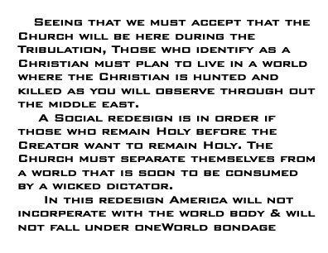

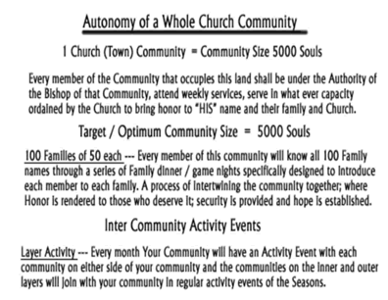
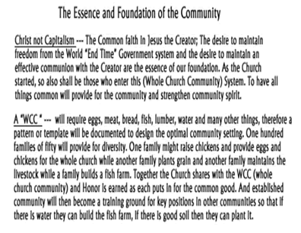
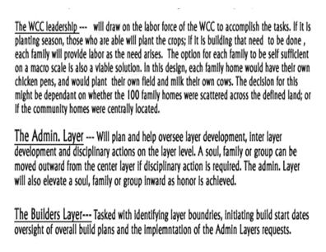
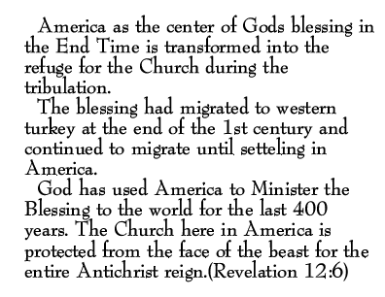
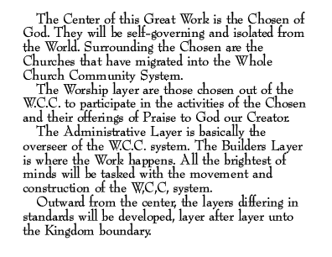
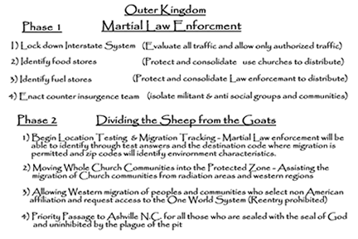
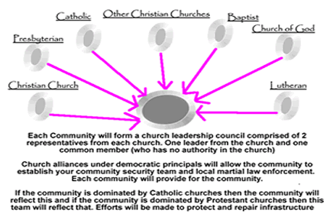
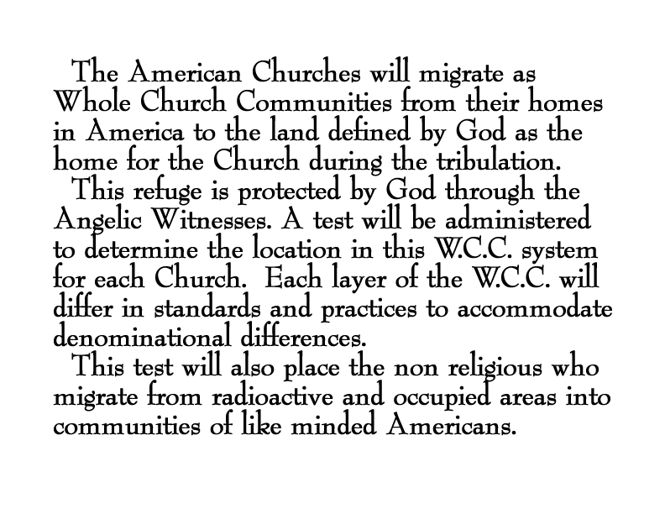

Reorganization Plan

This plan is a relocation effort to extract Christian communities from American cities and towns, into a safe environment that is wholly Christian controlled and therefore not subject to New World Order laws that run contrary to Christian principals. The implantation of Sheria (Muslim) law is prohibited in this Christian exclusion zone. Consider this time the “Latter Rain”, for the lost will be seeking hope and answers. Each church that is mentally prepared to minister to their local community will win the lost and strengthen their church. Families that had no interest in Jesus will be at your door, or at your outreach, attending your play and listening to your choir The use of theatrical presentations in your town will draw them in.

1) Assemble Church based security teams for local enforcement of Martial Law.
a) Send runners to churches with instructions to relay reorganization plans to other churches.
b) Identify safe houses along the routes to each church community.
c) Priority in the relocation process will be given to Christian communities fleeing radioactive areas and areas that have become unsafe for Christians.

- Identify Secure Areas and protect secure areas, migrate Christians from unsafe areas.
a) Some areas are predominantly Christian and will be easier to manage while other areas are NonChristian and will be unsafe for the Christian.
b) Retrieve or protect food, fuel & medical supplies.

- Work with State and local governments to facilitate this process while understanding that other communities will fall under their State and local government control. Each community in America is different even Paul pointed out that he came from no mean city.(act 21:39) some communities will not have many prochristian minded souls and are better off avoided.

- This evacuation effort will take almost 2 years, therefore, if you own a farm you might need to harvest another crop before you leave. Every effort must be made to capitalize from every asset so that the needs of the people can be met. Local governments will be in need of your grain, your milk, and your water. Be merciful and lend to the need. Those who are migrated will need to plant crops quickly and set up food stores.

Special Concerns
1) The Children. We need to insulate the children from the fear and confusion.
2) Use the elderly with a good report to watch over the needs and welfare of the children. Activities of Games and continued education (school) will be helpful.
3) Feeding stations + set up feeding stations at churches (1 meal a Day)
- While feeding people inform them, sing to them and Preach to them.
- Identify special needs of those who come to your churches. Showing you care in this time of need will overcome many problems(better a friend than and enemy)

Special Notes
In our supply on demand economy, things are sent “just in time” No more Ships will be resupplying our shelves. We will need to secure and reuse everything. A 2-liter coke bottle becomes a 2-liter water canteen, ect. A Commune style community will be developed from each Church community. Electrical services and other utilities will not be reestablished in most cases.
Infiltration of our society from foreign transplants with predefined objectives is expected so assign security teams to deal with any unexpected circumstances.

An area of Refuge in the eastern U.S. has been allocated to relocate your church commune, or the portion of your church commune that desires to be set apart for the Lords use. When the location for your commune has been determined and the transportation team arrives at your site, everyone desiring to relocate into this new work must be ready to depart with whatever they can manage to carry. All other items will be considered community property and shared. Everyone will submit to the church pastor if you have one, or one will be provided for your church. Do not leave without the authorized security transport team. They will have identified the safest route for this transportation effort. Your church will then become a community transfer station for communities that are relocating from father away. The elimination of access to the electronic culture will present significant obstacles to this redesign of our community structure. To compensate for this backlash people must be kept busy doing something. It is recommended that each community develop a weekly theatrical production. By employing the effort in preparation of these weekly plays, you will lessen the impact of the loss of the electronic culture. Some will not respond to this therapy and will need personal and group sessions.

As a Prophet of God I can see into the future. I have discovered a Plan to fundamentally change America and the Church to fit into the One World Religious System. Incorporated in this plan is the removal of your electronic grid system, foreign-armed implants and a host of other problems. America will need to regroup and reinvent itself as this calamity presents itself. I have been sent from God to establish the refuge for the Church in eastern America. Surrounding this refuge for the Church is the remaining part of America that retains freedom from the World System.

With the loss of the electronic society, America’s Super Power status will be inoperable and each community, state and region will face diverse threats and circumstances. These threats will include instigated race riots, armed militant groups imposing their will on regions, natural disasters and the effects of nuclear war. A total breakdown of civilized society and law will transform America into third world status. I have used the Word of God to reeducate you concerning your false expectations of a pretribulational Rapture.

Reason mandates that a restructuring of the Church is in order if she is to maintain any expectation of hope in enduring the “End Time” Everything you see happening in the world is part of a predefined plan The religions are playing an integral part in this deception and you will discover many you thought to be holy were under this spell of unification between the unholy and the holy bringing the true believers under the bondage of this one world religion.

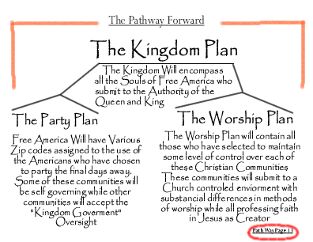
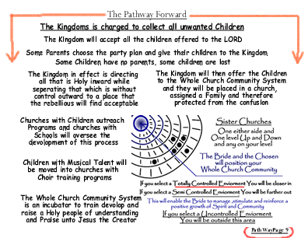

The Gospel of Mary According to Luke

Luke is most favored of the Lord, for He (God) allowed Luke’s record to preserve the Actions of Creator God. Through This Creation within us, as a Part of Himself in humanity, He (God) formed what we call the “Church”. The Church was separate from the world, and afraid to show their face until God supernaturally inhabited them on that Pentecost day some 2000 years ago. What might have seemed, as a parlor trick soon became a movement that concerned the Roman Government.

As we examine Luke’s record, and compare it to Matthew, Mark, and John; we find a very strange thing. It’s almost like Luke was a genie, he was everywhere, through all of the time of the whole story of Jesus, and the whole story of the establishment of the Church.

The cumbersome dilemma is that Luke is only mentioned in the Bible twice by Paul. This was within a year or two of Paul’s death, when Paul was in Jail at Rome and Luke was mentioned to be there as Paul wrote to the church of (Colossians) that he had never visited. Luke is also mentioned in Paul’s last letter addressed to Timothy where Paul mentioned his expectation to die and that he had fought the good fight and was ready to die.

The solution for this dilemma is found in Luke’s first words of his first document that we refer to as the gospel of Luke.

Luke 1:1-2 Forasmuch as many have taken in hand to set forth in order a declaration of those things which are most surely believed among us, Even as they delivered them unto us, which from the beginning were eyewitnesses, and ministers of the word;

It doesn’t take a rocket scientist to establish the fact that Luke is telling you the stories that he was told from the eyewitness to the very actions that they are giving an account of.

Luke 1:3 It seemed good to me also, having had perfect understanding of all things from the very first, to write unto thee in order, most excellent Theophilus,

Again Luke is claiming here that He has the whole story from the very beginning. Luke had recorded the testimony of Mary even from the time when Jesus’ mother Mary visited Elisabeth, John the Baptist’ mother who was her cousin and wife to Zacharias, Priest of the Temple.

To have a clearer view of Luke’s entrance into the Faith, we must place ourselves in a multi story home in Troas (Acts 20:6) the Night before Paul was to leave by ship on his journey to Jerusalem. A doctor was in this home listening to this traveling preacher who seemed to know and have the respect of everyone. Late in the night as Paul continued to rehearse stories of his journeys to the believers, a man who was listening while sitting in a third story window fell down dead right in front of them.

Luke was not equipped to render medical attention to a person who was already deceased. Paul stepped in and raised this man to life in front of them all. It was not exactly Paul, but Paul’s prayer to Jesus that was the Power applied to this task. We notice Luke’s addition to Paul’s team as Luke claimed to be a companion of Paul and from that moment forward Luke seem never to leave his side.

Acts 20:13 And we went before to ship, and sailed unto Assos, there intending to take in Paul: for so had he appointed, minding himself to go afoot.
Luke having seen life drawn back into a human, signed on to Paul’s journey and this is where Luke’s personal part of the story begins. From this point on, through the rest of the book of Acts Luke give us his perspective as an eye witness to the circumstances he documents. Every other account was from someone’s memory and he wrote it down playing the part of historian for a historical record of the movement of the Hand of God through His Son and ending with Paul’s death.

Within a few weeks of Luke Joining Paul’s Journey, Luke found himself in Downtown Jerusalem and escorted into the presence of Jesus’ mother Mary, the blessed mother of our Lord. Paul’s Life in now in Jeopardy, Luke naturally took refuge with his companions friend and missionary partner Mark, the friend of Jesus’ mother where Peter took refuge from the Roman Government the night that King Herod took the Apostle James life and Peter escaped from the Jail.

Acts 12:11-12 And when Peter was come to himself, he said, Now I know of a surety, that the Lord hath sent his angel, and hath delivered me out of the hand of Herod, and from all the expectation of the people of the Jews. And when he had considered the thing, he came to the house of Mary the mother of John, whose surname was Mark; where many were gathered together praying.

They were gathered together praying at Mark’s mothers home, kind of like home church. Mary the Mother of Gods’ Son Jesus was best friends with Mary Magdalene and Marks mother Mary as well as John and James mother Mary.

John 19:25 Now there stood by the cross of Jesus his mother, and his mother's sister, Mary the wife of Cleophas, and Mary Magdalene.

The Gospel of John records for us how these three Mary’s who followed Jesus are found at His feet sharing His most disparaging moment on the cross. We also find in that same text where Jesus entrusts His mother Mary into John’s care at His Death. Mary’s own account to Luke adds that this Mary Magdalene was the one that Jesus had cast out 7 demonic spirits.

Luke 8:2 And certain women, which had been healed of evil spirits and infirmities, Mary called Magdalene, out of whom went seven devils,

It is evident that the blessed mother Mary’s testimony helped Luke fill in the details of the early church. Specific details about how this Rhoda fails to open the gate for Peter at John Mark’s mothers home the night that Mary’s best friends son James (one of the 12) was killed shows a woman’s touch. Obviously Mary, Jesus’ mother would be at her best friends side at the loss of her son and that is why Luke records this in Acts chapter 12.

Acts 12:13-15 And as Peter knocked at the door of the gate, a damsel came to hearken, named Rhoda. And when she knew Peter's voice, she opened not the gate for gladness, but ran in, and told how Peter stood before the gate. And they said unto her, Thou art mad. But she constantly affirmed that it was even so. Then said they, It is his angel.

The first place we can see Luke’s intimate personal relationship with Mary the Blessed Mother of Jesus is when he identifies Mary’s hidden heart felt actions that she would only convey to a personal friend.

Luke 2:19 But Mary kept all these things, and pondered them in her heart.

The account of Luke is littered with the testimony of Mary; containing only things Mary would know, giving Luke’s Gospel the perspective of a woman. Take for instance the story of Elisabeth, John the Baptists mothers proclamation that the infant within her womb jumped for Joy when hearing the voice of Mary. This was part of Mary’s memory and testimony of Her part in the movement of the Hand of God.

How excellent is the record of Mary’s cousin Elisabeth’s miraculous birth of the prophet John the Baptist, for she was very old and her husband was the priest that burnt incense before God on the Holy day. This brings to light that only Mary would have held these things and God purposed Luke to preserve the memories of Mary in this “Gospel according to Mary”.

Through out Luke’s account we see the things that Mary remembered about her Son and His journey through the human life.

Mary begins her testimony to Luke with the Angel Gabriel’s Prophecy to Zacharias, and as a prayer offered by a priest is answered by God, the Creator calls for a recorder to make record of the movement of the Hand of God in His Creation. By preserving Jesus’ mother Mary until the arrival of Luke, allowed God to document Mary’s record of Great blessing upon her lineage and identified her as the principal player in the movement of Gods’ Hand to His people Israel. The Israelite was taught to memorize their lineage from an early age, for from this lineage stems their Honor and placement within the kingdom of God. Mary’s lineage was joined hard and fast to the Levitical priesthood, the order of the temple service and of the daughters of Aaron.

God chose the very best woman on earth in Mary, Holy and related to King David through David’s son Nathan. Solomon his brother had brought a curse from God upon his lineage and so God chose his brother Nathan’ lineage to bare the Holy Blessing of the Chosen Messiah. This Honor was the highest imaginable thought for a young Daughter of King David, to bare the Messiah. The Holy attitude of Faith would be this young virgins only correct response, “May it be even as you have proclaimed it”! God loves Faith, and the Faith this young woman showed in the Messenger of Gods’ Plan, gave this Holy and Blessed Mother of Jesus a “Gospel according to Mary” through Luke’s Pen.

Only a Woman would remember the response Jesus gave to the audience of His teaching when it was stated that His mother was present in the crowd.

Luke 8:20-21 And it was told him by certain which said, Thy mother and thy brethren stand without, desiring to see thee. And he answered and said unto them, My mother and my brethren are these which hear the word of God, and do it.

No doubt His mother felt that response inside and it would be unlikely that she would omit it. Her best friends also named Mary would be referred to in Her record and we find that also to be the case. Mary identifies her friend Mary Magdalene as the one who Jesus approached in His new body after His resurrection and again only a woman would have a record of all the other woman that were with her.

Luke 24:10 It was Mary Magdalene, and Joanna, and Mary the mother of James, and other women that were with them, which told these things unto the apostles.

Mary was passionate for the Honor of Her family’s story and the interaction of God the Creator’s Hand in Identifying the Chosen Messiah within her bloodline and lineage. The Spirit of God spoke through Her as she revealed the details to Luke. She told him of the Angel that had spoken to her and her cousin. She remembered being publicly set aside by her son as He assumed the Position of Priest and Preacher. Mary was one of her Son’s biggest fans, she would go to hear Him speak and the spirit of God used Mary’s memory to preserve such splendor and detail about the heritage of this specific strain of the lineage of King David.

Mary recalls when she reprimanded this child Jesus for not returning with them from their annual Passover Jerusalem trip. Even at the time of Luke’s recording of Mary’s testimony, She still remembered him as her son that she gave birth to and taught to read and write. How extraordinary it must have been for her to play such a Personal part in the supernatural work of God, to see the child perform the supernatural and then assume His position in Heaven as the Son of God and the Creator of man.

Luke 2:43 And when they had fulfilled the days, as they returned, the child Jesus tarried behind in Jerusalem; and Joseph and his mother knew not of it.

Luke 2:47-48 And all that heard him were astonished at his understanding and answers. And when they saw him, they were amazed: and his mother said unto him, Son, why hast thou thus dealt with us? behold, thy father and I have sought thee sorrowing.

This one account should verify to the casual observer as to the authenticity of the original observers identity being his very mother, the blessed Mary’s testimony. The Favor of God on this Woman shall never be equaled. I often wonder how much of the Apostle Paul’s arranging we see in this letter of Luke?

Paul might have prayed to God that the Record was lacking and God sent Luke into Paul’s life to document for Paul the record we see here. Paul was the one to see the need and fill it. Constantly Paul was attempting to prove his worth before God. It is most probable that Paul purposely assisted Luke in building this Historical record of Luke. Luke might have played Paul’s investigative reporter in which case Paul might deserve partial credit for the production of Mary’s Gospel. What is so precious is that this testimony is authentic and worthy of our trust and worthy of our Hope in our God and His Righteousness and Perfection.

Luke 2:51 And he went down with them, and came to Nazareth, and was subject unto them: but his mother kept all these sayings in her heart Luke 2:19 But Mary kept all these things, and pondered them in her heart.

Luke is identifying the Author of this material as he is taking the notes for the rough draft. He most probably wrote down “Mary just kept thinking about these things” as Mary kept his pen busy with details of this sermon or of that gathering He spoke at, and the details as to what was said. Interview after interview Luke built this manuscript on the foundation of the testimony of Mary the Mother of Jesus, and everyone else he met in the way.

Luke 1:2-3 Even as they delivered them unto us, which from the beginning were eyewitnesses, and ministers of the word; It seemed good to me also, having had perfect understanding of all things from the very first, to write unto thee in order, most excellent Theophilus,

Luke’s report that those who told him these things were “Eye Witnesses” and that His knowledge covers from the first movement of God’s hand unto the end of Paul’s life. The fact that Luke kept himself out of the story, leads me to believe this compiling of the Body of the work filtered through Paul’s hands. This would explain why Paul referred to Luke as “beloved Luke”

Colossians 4:14 Luke, the beloved physician, and Demas, greet you.

Paul was a wise one; he knew the value and need for the preservation of these things. He knew that the Christians needed to have a firm foundation documented so that those who would seek God should find Him through even His mothers’ record of His great Journey and how His Creation responded to Him.

We are provided the viewpoint from a common workingman in Peter’s record through Mark’s Gospel. We receive the real time record through Matthews Gospel. Through John the Beloved we see the best friends in depth understanding that this Man had God the Creator living inside Him. John was the most precious friend someone could have. To gain the attention of Jesus and to have your dinner seating assigned next to the Messiah is testament to itself that John was very special.

Luke had access to Marks writings as well as other accounts, but as Wisdom would have it; Luke having obtained access to the principal character, assumed the responsibility to set forth the most accurate chronicle of the movement of God. Having Mary as his eyewitness brought clarity to the splendor and harmony of the new way in which God would dwell among and in His possession.

God maintained a record of Jesus’ lineage in this chosen Nation as we see in Mary’s lineage documented in Luke chapter three. This New Covenant of God was implemented by one’s Faith toward Jesus as their grafting in point to the Jewish lineage or root system. As we accept the testimony of a believer, and we are Born Again, we are assimilated into this new spiritual lineage tract. One might suggest that you are of the lineage of the one who won you into the family of faith. Consider the prayer Jesus made in John 17:20;

John 17:9 I pray for them: I pray not for the world, but for them which thou hast given me; for they are thine. John 17:20 Neither pray I for these alone, but for them also which shall believe on me through their word;

Those who believe on Jesus through the word of others are grafted into this Spiritual lineage that culminates with the 11 apostles and Jesus as the Chief Corner Stone. This lineage then is traceable all the way back to Abraham and the promise. Eventually the lineage of the believer is derived from the first man Adam.

To believe on the testimony of Mary through Luke’s record adds assurance that your lineage is embedded within the bloodline of King David for Mary’s Son is the Son of David, the King of Creation.

The fact that Luke documented His work at such a distant time from the Olivet Discourse when Jesus took aside four of His twelve to privately expound on the end of time and His return for His church; explains why Luke’s version of what Jesus told Peter, James, John and Andrew, drastically differs from the other accounts.

Mark 13:3-4 And as he sat upon the mount of Olives over against the temple, Peter and James and John and Andrew asked him privately, Tell us, when shall these things be? and what shall be the sign when all these things shall be fulfilled?

As Luke finished writing his account, Jerusalem had become a spectacle to the known world with the Roman army’s destruction of Jerusalem and the leading away captive of the surviving Jews to be sold into the Roman Empire as slaves. The temple had been destroyed causing Luke to update the prophecy contained in the Olivet discourse to reflect what he thought was the fulfillment of the prophecy. This is why you will find Luke’s account stating that the Jews were carried into all nations. Luke believed this prophecy was fulfilled at this point, however there is yet one more temple to be build and destroyed before this prophecy can be fulfilled and then Christ Jesus shall return.

Luke 21:24 And they shall fall by the edge of the sword, and shall be led away captive into all nations: and Jerusalem shall be trodden down of the Gentiles, until the times of the Gentiles be fulfilled

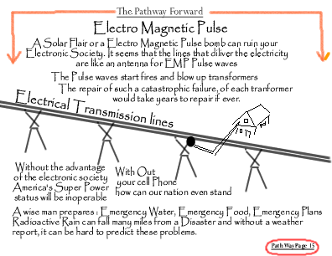

It is recommended that you produce a hard copy of this material and then pass it on to your Christian friends. This is the back up plan should our country fail from the Electromatic Pulse (EMP)

Russia is moving its tanks and weaponry in to Syria as the Briton House of Commons is mandating the removal of the Syrian Leader.

Israel will be forced to act and Russia’s “No Fly Zone” in Syria will soon be active. The odds of a Nuclear War has increased drastically.

The rally point for the Christians is in the Bible belt here in eastern America.

May the God of Heaven bless you with the wisdom to understand the time you live in and the need for uncommon actions in an uncommon time.

I look forward to working with you and your Church in this blessed area Ordained of our Creator to sustained His Church through
The Tribulation.

North Wind
Prophet of the Most High God
